**PROJECT PLANNING PHASE**

**SPIRIT DELIVERY PLAN**

DATE

TEAM ID

PROJECT NAME

AI

-

powered Nutrition Analyzer for Fitness Enthusiasts

**Spirit Delivery Plan:**

The delivery plan of project deliverables is a strategic element for every Project Manager.

The goal of every project is, in fact, to produce a result that serves a specific purpose. With

the word “purpose “, we can mean the most disparate goals: a softwar

e program, a chair, a

building, a translation, etc.… In Project Spirit Delivery Planning is one of the processes of

completing the project and Show Casing the Time Line of the Project Planning. This

Delivery plan help to understanding the process and Work

Flow of the Project working by the

Team Mates. Every Single Modules are assigned to the team mates to show case their work

and contribution of developing the Project.

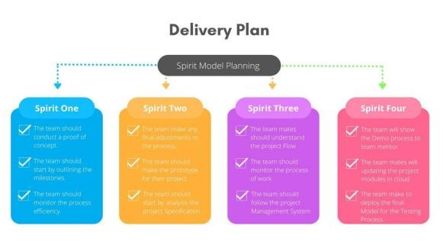

18 November 2022

PNT2022TMID39001